**European Pattern Recognition - Renewable Energy Impact**

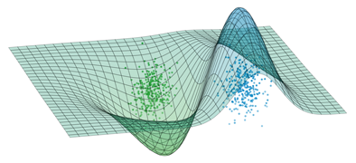

**Work Package 7: Inertia Support**

SCOPE AND REQUIREMENT DETERMINATION

**Erencan Duymaz**

**Dr. Ozan Keysan**

**December 2017**

**  **

**Contents**

1 Introduction 3

2 Scope 4

3 Current pmsg wınd turbınes 5

4 Wınd turbıne propertıes 8

4.1 Aerodynamıc model detaıls 9

4.2 Mechanıcal model detaıls 9

4.3 Pmsg detaıls 9

4.4 Back-to-back converter detaıls 9

4.5 Fılter detaıls 9

5 Requırements 10

6 Outputs 11

7 Conclusıon 12

8 References 13

# Introduction

Electricity grid is subject to change with the increasing number of loads and generation units. For this decade, most of the newly installed generation units is renewable energy sources. As a result, the share of the renewable sources in the installed capacity has reached significant levels. Even though renewable energy has promising effects on the environment compared to the conventional energy sources which are based upon coal or natural gas, they also bring operational challenges. One of these challenges is the frequency stability problem.

Frequency of the grid is maintained between pre-defined values by using the primary and secondary controllers. Primary controllers are defined for each generation unit and it is basically changing the active power output based on the frequency deviation from the nominal value. Their action is occurred from a few seconds to minutes. By the primary controller action, the decrease in the frequency is arrested. Secondary controller action is enabled by system operator and it brings the frequency to the nominal value in the duration of a few minutes to hours. However, the decrease in the frequency is captured or arrested by the primary controllers and inertial support action. Conventional synchronous generators are basic synchronous generators and they have huge rotating bodies (inertia). As the frequency decreases, synchronous speed of such generators also decrease. Therefore, such slow down operation inherently release the energy stored in the inertia of generators. This is why strong grids (grid with huge inertia) experience small frequency deviations.

Nonetheless, renewable energy sources do not have inertial support ability “inherently”. In other words, their action does not depend on the deviation on the grid frequency. In the wind turbine applications with full scale power converter, active and reactive power can be controlled easily. However, the power captured by wind for the time being is constant. In order to increase the power injected to grid, stored energy either in turbine inertia or DC bus capacitance should be used. Therefore, it is possible to emulate synchronous generator behavior in such applications by relating the turbine output power with frequency deviation (rate of change of frequency) in the grid side.



Figure 1: Energy Flow in Wind Turbine Applications with Full Scale Power Electronics

In the *European Pattern Recognition - Renewable Energy Impact* project, WP7 deals with the Inertial Support. In this work package, EnerjiSA and Middle East Technical University collaboration will evaluate the inertial support of the, BARES wind farm of EnerjiSA. The previous report has been revealed the literature review for the inertial support mechanisms for wind energy conversion systems. The objective of this report is the scope and requirement determination for the WP7. Current Permanent Magnet Synchronous Generator (PMSG) Wind Turbines will also be explained. The outputs of this study will also be defined at the end of this report.

# Scope

The scope of this study is evaluating the potential of the wind farm, BARES, for the inertial support. In order to evaluate the capacity and the potential of the wind farm for inertial support, the wind farm should be modelled on the simulation environment. Then the real measurements from wind farm can be utilized and the frequency deviations can be investigated.

The inputs of this study will be the wind farm properties and the real measurements taken from field. These data will be utilized to reach a conclusion which includes the capacity of such inertial support and its economical results.

The frequency changes in the electricity grid depending on the balance between supply and demand. Therefore, a generation unit outage or instant high amount of load connection causes frequency to decline. The measurement taken from BARES will be used in order to recreate the disturbance in the simulation environment. The grid in the simulation area will be exposed to a generation unit outage such that frequency decline similar to the measurement is achieved. After that same outage will be tested under the case in which wind farm has inertial support ability.

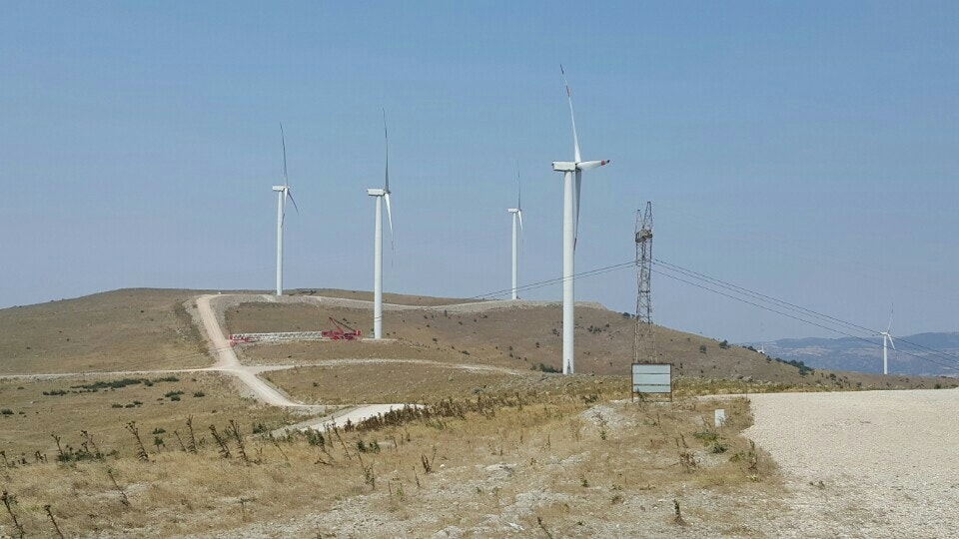

Figure 2: BARES wind farm

# Current pmsg wınd turbınes

The main control diagram of the PMSG wind turbine is given below. In the figure, the aerodynamic model represents the wind turbine structure which captures power from the air. The mechanical model represents the generator and wind turbine connection via gearbox.

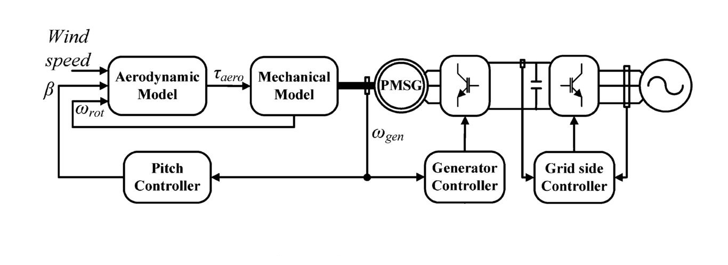

Figure 3:Main Control Diagram of the PMSG Wind Turbine[1]

The aerodynamic power captured from wind depends on the wind speed, pitch angle and the rotational speed. The term power coefficient, Cp is the aerodynamic efficiency of the operating point of the wind turbine. Therefore, the responsibility of pitch controller and generator side controller is to maintain the maximum efficiency. The variation of power coefficient, Cp, is given in Figure 4.

|  |  |
| --- | --- |
|  | (1) |

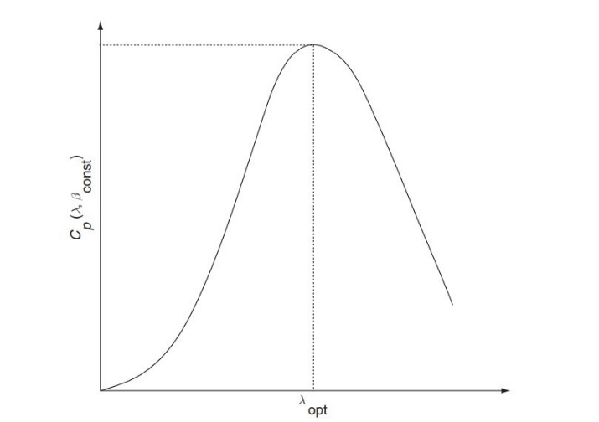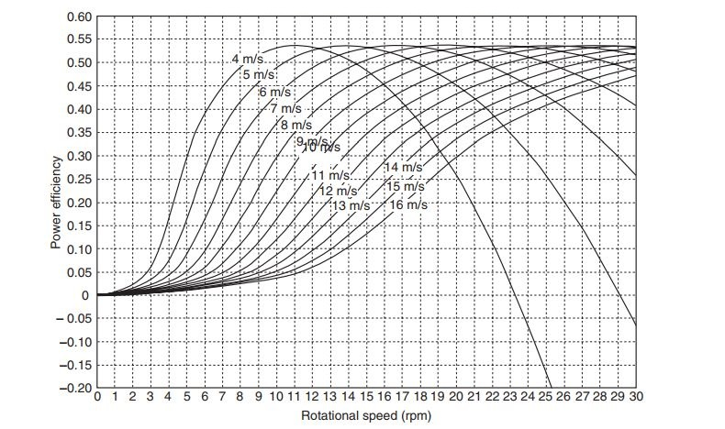

(b)

(a)

Figure 4:(a) Power Coefficient for a constant pitch angle (b) Power Coefficient for different pitch angle [2]

Permanent magnet coupled to wind turbine shaft is connected to grid with the Back-to-Back(BTB) Converter structure. This structure gives operator freedom of control. Therefore, by making use of BTB converter, the operator can define active and reactive power set points independently. BTB converter is composed of two different structure. The first one is the generator or machine side controller (MSC) which is connected to machine side. The other one is connected to grid side and hence it is called grid side converter (GSC).

The responsibilities are shared between these converters. MSC is responsible for speed reference and the active power reference meanwhile the GSC is responsible for the reactive power reference (also the power factor) and the DC voltage reference. As seen the figure below, the generator speed is dictated by controlling the q-axis current. This generator speed should be the maximum power point which is generally taken from look up table.



Figure 5: Machine Side Controller Diagram [3]

Grid Side Controller is responsible for maintaining constant DC voltage and the reactive power amount. Reactive power amount can be set by controlling the q-axis current. For normal operation, wind turbines and also other renewable sources are desired to operate at unity power factor. This is achieved by setting zero current for the q-axis. Note that for the LVRT capabilities, this set point would change time to time. GSC is also responsible for maintaining the constant voltage in the DC link. The diagram for GSC is given for a wind turbine which is connected to grid with L filter.



Figure 6: Grid Side Controller Diagram[3]

# Wınd turbıne propertıes

BARES is a Wind Farm located in Balıkesir with 52 Wind Turbines of 142.5 MW. Each turbine has a power rating of 2.75 MW. Turbine is manufactured by General Electric and its model is GE 2.75-103. Wind farm is connected to 154 kV network with two 80/110 MVA transformers. There are three measurement devices placed in the wind farm. One of the measurements are placed in a turbine output. Others are placed in 33 kV and 154 kV busbars.

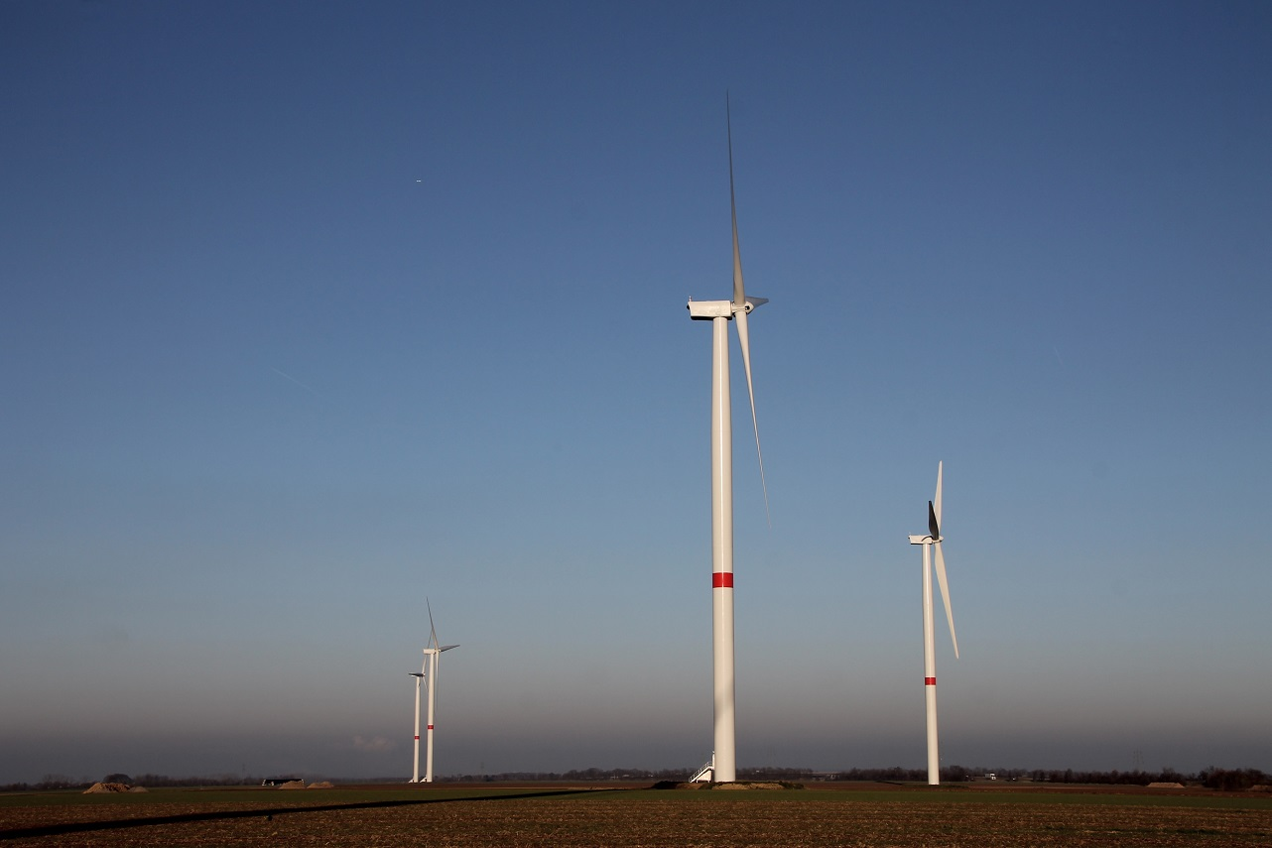

Figure 7:GE 2.75 Wind Turbine

## Aerodynamıc model detaıls

|  |  |  |
| --- | --- | --- |
| **Parameter** | **Value** | **Unit** |
| Wind Turbine Power | 2.75 | MW |
| Rotor Diameter | 103 | m |
| One Blade Inertia | 4340000 | kg.m2/kg |

## Mechanıcal model detaıls

|  |  |  |
| --- | --- | --- |
| **Parameter** | **Value** | **Unit** |
| Gear Ratio | 1:117.4 | - |
| Gearbox Inertia | To be obtained later | kg.m2/kg |
| Gearbox Efficiency | To be obtained later | % |

## Pmsg detaıls

|  |  |  |
| --- | --- | --- |
| **Parameter** | **Value** | **Unit** |
| Generator Rating | 3.04 | MVA |
| Active Power | 2.75 | MW |
| Generator Inertia | To be obtained later | kg.m2/kg |
| Generator Voltage Rating | 690 | V |
| Generator Flux | To be obtained later | V.s |
| d-q axis Leakage Inductances | To be obtained later | H |
| Stator Resistance | To be obtained later | Ω |

## Back-to-back converter detaıls

|  |  |  |
| --- | --- | --- |
| **Parameter** | **Value** | **Unit** |
| Detailed Control Diagram | To be obtained later | **-** |
| PI Compensator Constants | To be obtained later | **-** |
| DC Link Voltage | 1073 | V |
| DC Link Capacitance | 27000 | μF |
| Drive Switching Frequency | To be obtained later | kHz |

## Fılter detaıls

|  |  |  |
| --- | --- | --- |
| **Parameter** | **Value** | **Unit** |
| Filter Type | LCL Filter | - |
| Inductance/s | 400,800 | μH |
| Capacitance (if any) | 185 | μF |

# Requırements

Due to the fact that this study is related to the inertial support, frequency measurement resolution should be high. Therefore, frequency measurements per seconds should be up to 100 measurements per second. However, the existing measurement devices might not provide such resolution. Therefore, the maximum number of frequency measurement should be provided in order to obtain accurate results for this study. The frequency measurements should be obtained from 100 ms data window.

Another issue for frequency measurement is the triggering criteria. For this issue, ENTOSE report has been considered. According to [4], it is observed that almost 20% system imbalance creates frequency disturbances with 0.5 -1 Hz/s RoCoF values. Therefore, 0.1 Hz/s can be chosen as triggering criteria for this project. In this way, significant frequency disturbances in the electricity grid can be captured.

The measurements are taken from BARES wind farm with the Metrum devices. It is understood that current Metrum devices in the field are not able to supply required measurement resolution. Instead, Metrum has offered to supply frequency measurements taken from Swedish TSO.

# Outputs

The requested data will be used for the modelling of the wind farm in BARES. After the modelling, the frequency measurements will be utilized for the possible frequency disturbances. By using these frequency disturbances, the differences between existing and modified conditions will be observed. At the end of this study following outputs will be presented.

|  |  |
| --- | --- |
| **Outputs** | **Unit** |
| Improvement in Frequency Nadir | % and Hz |
| Improvement in RoCoF | % and Hz/s |
| Cost | kWh |

It should be noted that all these outputs will be dependent on the active power increase of the Wind Turbine, support duration and the grid generation profile. Therefore, a set of outputs is supposed to be created at the end of this study.

Moreover, the inertial support will distort the Maximum Power Point Tracking algorithm. Therefore, it is expected to cause some energy lost in the generation. This is why an economic cost will also be presented.

# Conclusıon

In this report, scope and requirement determination for WP7 is presented. Which inputs and outputs will be included in the study is clearly stated. As it is stated in the previous section, the main results will be improvement in frequency nadir, improvement in the rate of change of frequency and the economic cost for such modification will be presented for each study case. These study cases can be high or low wind speed or power generation profiles.

One other issue is related to the accuracy of the outputs. In other words, the difference between simulation environment and the real life is also important. The outputs will have high accuracy if all required parameters are presented. Any missing parameters will be refilled with parameters of similar wind turbines in the literature. However, such substitution will result in inaccuracy or errors in the outputs.

|  |  |  |  |  |  |  |  |  |  |  |
| --- | --- | --- | --- | --- | --- | --- | --- | --- | --- | --- |
| **Literature Review** |  |  |  |  |  |  |  |  |  |  |
| **Scope and Requirement Determination** |  |  |  |  |  |  |  |  |  |  |
| **Data Investigation, Pattern Determination** |  |  |  |  |  |  |  |  |  |  |
| **Algorithm Development** |  |  |  |  |  |  |  |  |  |  |
| **Project Closure** |  |  |  |  |  |  |  |  |  |  |
|  | Nov-17 | | Dec-17 | | Jan-18 | | Feb-18 | | Mar.18 | |

Figure 8: Timing and Work Packages

|  |  |
| --- | --- |
| **Deliverables** | **Date** |
| Report 3: Data Investigation | 5 January 2018 |
| Report 4: Algorithm Development | 9 March 2018 |
| Final Report: Project Closure | 30 March 2018 |

Figure 9: Deliverables and Report Dates

# References

[1] J. Licari, J. Ekanayake, and I. Moore, “Inertia response from full-power converter-based permanent magnet wind generators,” *J. Mod. Power Syst. Clean Energy*, vol. 1, no. 1, pp. 26–33, 2013.

[2] T. Ackermann, *Wind Power in Power Systems Edited by*, vol. 140, no. 1. 2005.

[3] T. Orłowska-Kowalska, F. Blaabjerg, and J. Rodríguez, *Advanced and intelligent control in power electronics and drives*. 2014.

[4] ENTSO-E, “Frequency Stability Evaluation Criteria for the Synchronous Zone of Continental Europe,” p. 25, 2016.